🎬 Product Dissection for Amazon Prime Videos

🌐 Company Overview
Amazon Prime Video, launched by Amazon in 2006, has revolutionized the way people watch and experience entertainment online. As a global streaming service offering a vast collection of movies, TV shows, and original productions, it has become a central hub for digital entertainment.
Integrated seamlessly within the Amazon ecosystem, Prime Video combines convenience, personalization, and high-quality streaming to engage millions of viewers worldwide. With its innovative features, diverse content library, and commitment to enhancing user experience, Amazon Prime Video stands as one of the leading platforms in the global streaming industry.

🔍 Product Dissection & Real-World Problems Solved
Amazon Prime Video has transformed the digital entertainment landscape through innovation and customer-centric design. By enabling users to explore and enjoy content tailored to their interests, it addresses several real-world challenges faced by modern viewers.

🎯 Problem 1: Limited Access to Quality Entertainment
Real-World Challenge:
Before streaming platforms, viewers struggled with limited access to global and high-quality content. Traditional TV schedules and regional restrictions created barriers.
Prime Video’s Solution:
📺 Offers on-demand access to a vast library of global and local movies, TV shows, and Amazon Originals.
🌎 Provides localized subtitles and dubbing, making entertainment accessible in multiple languages.
🔓 Breaks geographical barriers, allowing users worldwide to enjoy cinematic experiences anytime, anywhere.

🤔 Problem 2: Content Discovery in an Overloaded Digital Space
Real-World Challenge:
With thousands of titles available online, users often experience decision fatigue when choosing what to watch.
Prime Video’s Solution:
🤖 Uses AI and machine learning-based recommendation systems to suggest personalized content.
🎞️ Features like “Continue Watching,” “Watch Next,” and “Recommended for You” simplify discovery.
💡 Curates relevant titles based on viewing patterns and genre preferences.

📱 Problem 3: Inconsistent Viewing Experiences Across Devices
Real-World Challenge:
Unstable internet connections and device incompatibility often degrade video quality.
Prime Video’s Solution:
⚙️ Implements adaptive bitrate streaming that automatically adjusts video quality.
📶 Allows “Download for Offline Viewing” for uninterrupted entertainment.
💻 Ensures cross-device compatibility for phones, TVs, tablets, and desktops.

👨‍👩‍👧‍👦 Problem 4: Managing Diverse Audience Preferences
Real-World Challenge:
Families with multiple viewers need personalized recommendations and parental controls.
Prime Video’s Solution:
👤 Supports multiple user profiles under one account.
🎯 Maintains individual watch history, recommendations, and restrictions for each profile.
🧒 Includes parental control settings for safe and age-appropriate viewing.

🌏 Problem 5: Rising Demand for Localized & Original Content
Real-World Challenge:
Audiences increasingly crave stories that reflect their local cultures and languages.
Prime Video’s Solution:
🎬 Invests in regional productions and Amazon Originals across multiple countries.
🌐 Empowers regional creators while engaging global audiences.

🧩 In a Nutshell
Amazon Prime Video’s journey from a simple video-on-demand service to a global streaming powerhouse showcases its ability to identify real-world challenges and solve them through technology, personalization, and inclusivity.
By addressing accessibility, discovery, personalization, and localization, it has truly reshaped how people experience entertainment worldwide.

🚀 Top Features of Amazon Prime Video

👤 1. User Profiles
- Create multiple personalized profiles under one account.
- Each profile has its own watch history, recommendations, and parental controls.
- Ensures individualized experiences for every viewer.

🎞️ 2. Content Library
- Massive catalog of movies, TV shows, and Amazon Originals.
- Each title includes genre, cast, rating, language, and maturity level.
- Balances global diversity with local appeal.

📝 3. Watchlist (My Stuff)
- Users can bookmark favorite titles for later viewing.
- Simplifies content organization and tracking.
- Enhances recommendation algorithms by analyzing saved items.

📺 4. Playback & Viewing History
- Adaptive video playback ensures smooth streaming.
- Tracks activities like play, pause, and completion.
- Powers the “Continue Watching” feature for convenience.

💳 5. Transactions & Subscriptions
- Users can rent, buy, or subscribe to additional channels.
- Every transaction is securely processed and recorded.
- Expands flexibility and monetization options.

🧠 Schema Description
The Amazon Prime Video database schema efficiently manages and personalizes streaming for millions of users. It includes entities that represent users, profiles, content, watchlists, recommendations, and transactions — all interconnected to ensure smooth and scalable operations.

👤 1. User Entity
Purpose: Stores key account-level details.
Attributes:
- UserID (PK)
- Email
- Password (Encrypted)
- Subscription_Status
- Registration_Date
- Country

👪 2. Profile Entity
Purpose: Supports multiple personalized profiles under one account.
Attributes:
- ProfileID (PK)
- UserID (FK → Users)
- Profile_Name
- Age_Group
- Language_Preference

🎬 3. Content Entity
Purpose: Manages all available media.
Attributes:
- ContentID (PK)
- Title
- Genre
- Cast
- Release_Year
- Rating
- Language
- Content_Type

📋 4. Watchlist Entity
Purpose: Tracks content users plan to watch later.
Attributes:
- WatchlistID (PK)
- ProfileID (FK → Profiles)
- ContentID (FK → Content)
- Date_Added

📺 5. ViewingHistory Entity
Purpose: Records user viewing activities.
Attributes:
- HistoryID (PK)
- ProfileID (FK → Profiles)
- ContentID (FK → Content)
- Watch_Date
- Progress

💳 6. Transaction Entity
Purpose: Tracks purchases, rentals, and subscriptions.
Attributes:
- TransactionID (PK)
- UserID (FK → Users)
- ContentID (FK → Content)
- Transaction_Type
- Transaction_Date
- Amount

🤖 7. Recommendations Entity
Purpose: Stores AI-generated personalized content suggestions.
Attributes:
- RecommendationID (PK)
- ProfileID (FK → Profiles)
- ContentID (FK → Content)
- Recommendation_Date
- Reason

🔗 8. Relationships Between Entities
Relationship | Type | Description
User → Profiles | 1 → Many | A single user can have multiple profiles.
Profile → Watchlist | 1 → Many | Each profile maintains its own watchlist.
Profile → ViewingHistory | 1 → Many | Each profile has multiple viewing records.
User → Transactions | 1 → Many | A user can perform several transactions.
Content → Watchlist / ViewingHistory | Many → Many | Content can appear in many lists and histories.
Profile → Recommendations → Content | Many → Many | Profiles receive multiple recommended titles.

🧩 9. Summary
This schema forms the backbone of Prime Video’s platform, enabling:
🔐 Secure account management
🎭 Personalized experiences
🧾 Accurate transaction tracking
🎯 Smart content recommendations
📊 Scalable analytics and insights

ER Diagram:
Let’s construct an ER diagram that clearly illustrates the relationships and attributes of the entities within the Amazon Prime Video schema. This ER diagram visually represents how different components of the platform interact, providing a comprehensive understanding of its data structure. Through this diagram, one can gain a deeper insight into the intricate relationships among users, profiles, content, watchlists, viewing history, and transactions. By examining these connections, the diagram effectively highlights how Amazon Prime Video organizes, manages, and personalizes its vast digital ecosystem to deliver a seamless streaming experience for users worldwide.

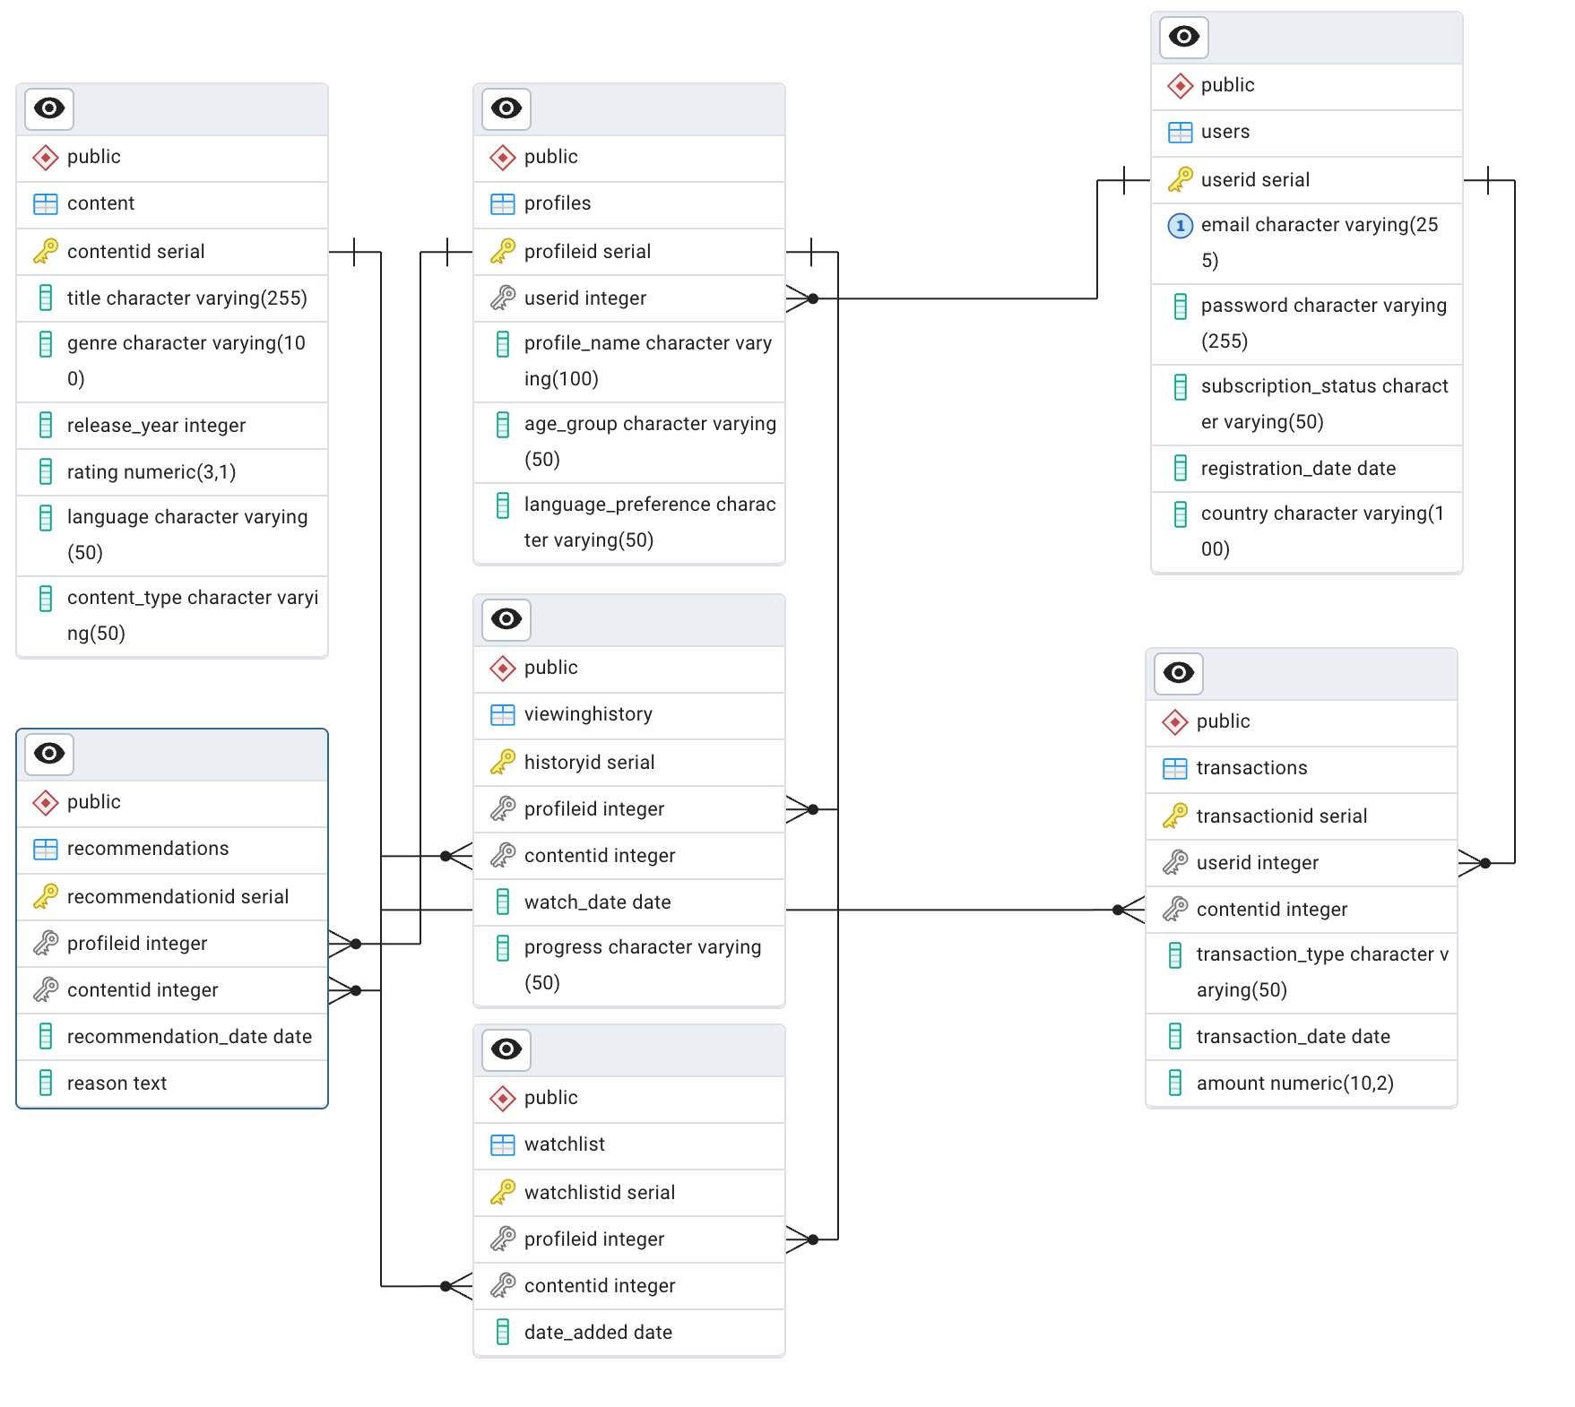
Fig: ERD for Amazon Prime Videos

How the Schema Supports Amazon Prime Video’s Objectives
- 🔄 Personalization:
By linking Profiles, ViewingHistory, and Recommendations, the schema enables customized recommendations and language preferences for each viewer.
- 📈 Scalability:
The modular structure allows the platform to handle millions of users and vast content libraries without performance degradation.
- 🔐 Data Integrity & Security:
Proper use of foreign keys and relationships ensures consistency, while encrypted user data safeguards privacy.
- 💡 Analytics & Insights:
The design allows easy extraction of insights such as most-watched genres, trending content, or regional viewership—empowering Amazon’s data-driven decision-making.

5. Conclusion
Amazon Prime Video has transformed the way people access and enjoy digital content, providing a seamless streaming experience across movies, TV shows, and Amazon Originals. The platform’s intricate data model, consisting of entities like users, profiles, content, watchlists, viewing history, recommendations, and transactions, forms the foundation for its smooth and personalized functionality. The database schema for Amazon Prime Video successfully captures both the technical and functional essence of the platform. Through well-defined relationships between users, profiles, and content, it ensures seamless integration of features like watchlists, recommendations, and transactions. This design ultimately enhances the user experience, supports platform scalability, and provides a strong foundation for personalized streaming services — reflecting how data architecture directly shapes the success of digital entertainment platforms. 🎥🌍

